Exercise 12: Projecting to Different Time Periods/Regions

Adam B. Smith, Danielle Svehla, & Camilo Sanín

July 31, 2017

Projecting to a time period or region different from the one in which the model was trained is easy to do once the model is trained, but it is important to understand the limitations of the model. Here you will:

1. Learn how to **project a model to a new time period or region**
2. Explore how **clamping** affects Maxent's predictions beyond the range of the training data
3. Analyze geographic space for the degree to which predictions are extrapolated using Multivariate Environmental Similarity Surface **(MESS) plots**

## Projecting to a new time period or place

Projecting a model to a new time period or region is as simple as replacing the raster stack in the predict() function to that for the period/place. Note that the raster names need to have the *exact* same names as the variables used in the model.

# future climate stack  
future <- stack(  
 list.files('./WORLDCLIM/2061-2080 RCP8pt5 ENSEMBLE/Study Region',   
 full.names=TRUE))  
  
# name rasters original names used in model  
names(future) <- paste0('WC', prefix(1:19, 2))  
  
# recall that we defined a select set of predictors...  
# limit the future climate stack to just these predictors  
# as including all layers increases computation time  
future <- future[[predictors]]  
  
# predict to raster  
futureMap <- predict(future, tunedModel,  
 filename='./Models/Model 08 Model Tuning - Beta Parameter/maxentPrediction2070sRcp85',  
 format='GTiff', overwrite=TRUE, type='cloglog')  
  
# calculate delta map  
delta <- futureMap - tunedMap  
  
# plot  
plot(rangeMap, main='Tuned Model: 1970-2000')  
plot(tunedMap, add=TRUE)  
sp::plot(countries, add=TRUE, border='gray45')  
plot(rangeMap, add=TRUE)  
points(records$longitude, records$latitude)

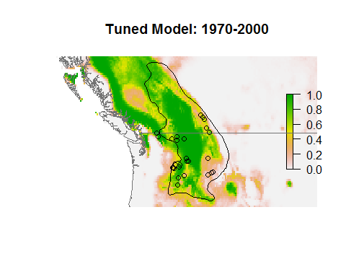

plot(rangeMap, main='Tuned Model: 2070s RCP8.5')  
plot(futureMap, add=TRUE)  
sp::plot(countries, add=TRUE, border='gray45')  
plot(rangeMap, add=TRUE)  
points(records$longitude, records$latitude)

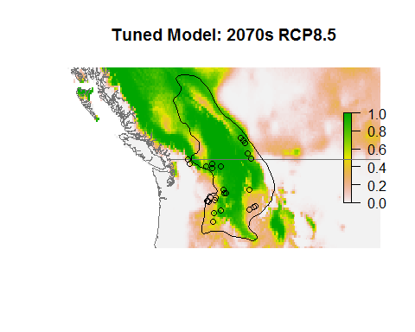

plot(rangeMap, main='Future - Present')  
plot(delta, add=TRUE)  
sp::plot(countries, add=TRUE, border='gray45')  
plot(rangeMap, add=TRUE)  
points(records$longitude, records$latitude)

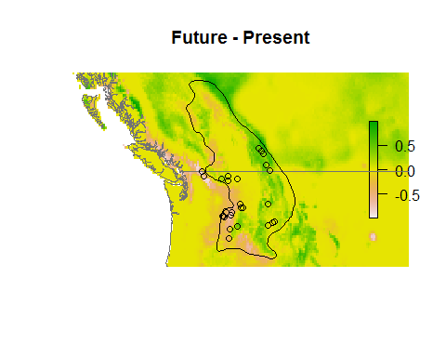

## Reflection

1. What does the model predict will happen to the species given unabated emissions?
2. Recall what the model is really modeling--the similarity between the climate where the species lives today and climate of the future. Is this the same as modeling the range of the species? What do distribution/niche models really tell you?

## Clamping

When a model predicts outside the range of environmental data used to train it, the result can be questionable. By default Maxent "clamps" predictions at the last value predicted within the range of the data used to train it. For example, if the maximum temperature (across presences and background sites) used to train a Maxent model is 37C and at 37C Maxent predicts a suitability of 0.35, then even if the model is presented with an absurdly high temperature (200C, say), it will still predict a suitability of 0.35.

You can see this by predicting to absurd values (even impossible values) of a variable.

# get min/max value of each predictor across study region  
minPred <- minValue(climate)  
maxPred <- maxValue(climate)  
names(minPred) <- names(maxPred) <- names(climate)  
  
# get median value of each predictor across species' presences  
medianPred <- apply(records[ , predictors], 2, median)  
  
# make data frame with median value of each predictor  
env <- as.data.frame(medianPred)  
env <- t(env)  
env <- env[rep(1, 100), ]  
  
# vary mean temperature of the warmest quarter (WC10) from -50 to 100 C  
env <- as.data.frame(env)  
env[ , 'WC10'] <- seq(-50, 100, length.out=100)  
rownames(env) <- 1:nrow(env)  
  
# predict (default is to clamp)  
predClamp <- predict(tunedModel, env, type='cloglog')  
predUnclamp <- predict(tunedModel, env, type='cloglog', clamp=FALSE)  
  
# graph  
plot(env$WC10, predClamp, xlab='Temp of Warmest Quarter (WC10)', ylab='Suitability',  
 main='Clamped Extrapolation', type='l', ylim=c(0, 1), lwd=3)  
lines(env$WC10, predUnclamp, col='red', lty='dotted')  
rug(records$WC10)  
abline(v=minPred[which(names(maxPred)=='WC10')], lty='dotted')  
abline(v=maxPred[which(names(maxPred)=='WC10')], lty='dotted')

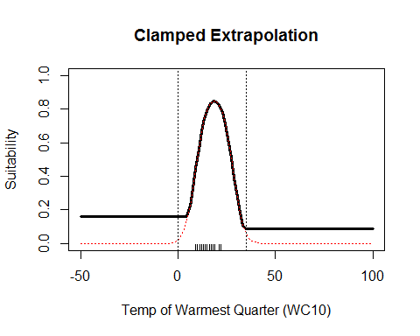

The model extrapolates beyond the vertical dotted lines (the min/max of WC01. Notice that below ~10C the prediction is clamped at ~0.18 all the way down to -50C--the species is apparently very cold tolerant! It is also clamped above ~75C.

This is an absurd example because real-world summer temperatures won't span -50 to 100 C, but it does illustrate important considerations for extrapolating to areas with different climate.

# MESS Maps

We can get an idea of how much any model has to extrapolate by calculating a Multivariate Environmental Similarity Surface (MESS) map. MESS maps are described in the appendix to [Elith, J., M. Kearney, and S. Phillips. 2010. The art of modeling range-shifting species. Methods in Ecology and Evolution 1:330-342.](http://dx.doi.org/10.1111/j.2041-210X.2010.00036.x)

extrapMap <- mess(x=future, v=targetBg[ , predictors])

plot(rangeMap, main='MESS')  
plot(extrapMap, add=TRUE)  
sp::plot(countries, add=TRUE)  
plot(rangeMap, add=TRUE)

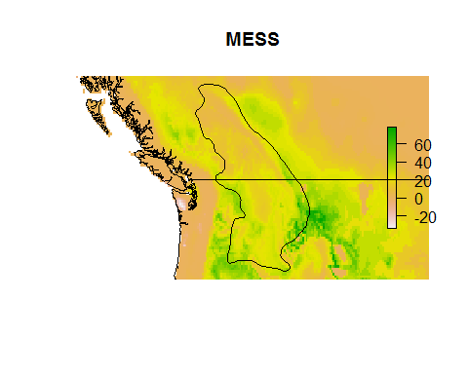

For a MESS map, any areas with a value <0 are being extrapolated into... the more negative, the greater the extrapolation. Values >0 (up to 100) require no extrapolation. Predictions into negative MESS areas are less likely to be trustworthy.

## Reflection

1. In what geographic areas will the model need to extrapolate if projected to the future? How should you interpret predictions into these areas?
2. What other conditions might affect extrapolation? Ergo, we explored extrapolation in single variables, but models also sometimes include interactions between variables.